Chapter 19, Problem 87.

For the circuit shown in Fig.19.129, use PSpice to obtain the t parameters. Assume ω = 1 rad/s.

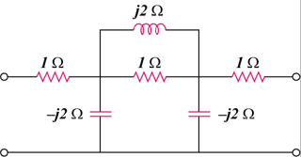

Figure 19.129
For Prob. 19.87.

